Task 6 : Laundry Services Responsive Issue

Problem Statement : Develop a responsive page for the laundry app we made in task 4.

Problem Description : We made the Hero Section of the laundry web app in Task 4 . But that works fine only on desktop when opened on mobile or tablet it breaks the layout we need to fix that using media Queries

Tasks :

* Navbar:
  + Text size for lists and logo and username gets smaller in tablet view
  + Hide the links in the mobile view just show the logo and username in the navbar.
  + Instead of display : inline use Flex.
* Hero Section:
  + Reduce the text sizes and image sizes in the tablet version..
  + Change the alignment and placing of image and text as shown in the sample output.
    - Hint :- Try using flex direction column

Submission Guidelines :-

* Deploy your code to netlify make sure to name your html file as index.html.
* If you don’t know how to deploy on netlify, watch this video : <https://youtu.be/Ii2Y4i4_i-o>
* Submit the Deployed Link below in the same task number
* Submission link :- [https://upskillmafia.com/mern/dashboard/tasks](http://upskillmafia.com/mern/dashboard/tasks)

| **Note :** You can take help from **Internet** or You can also connect with upskill Mafia **Mentors** |
| --- |

**Sample Outputs:-**

**Desktop:-**

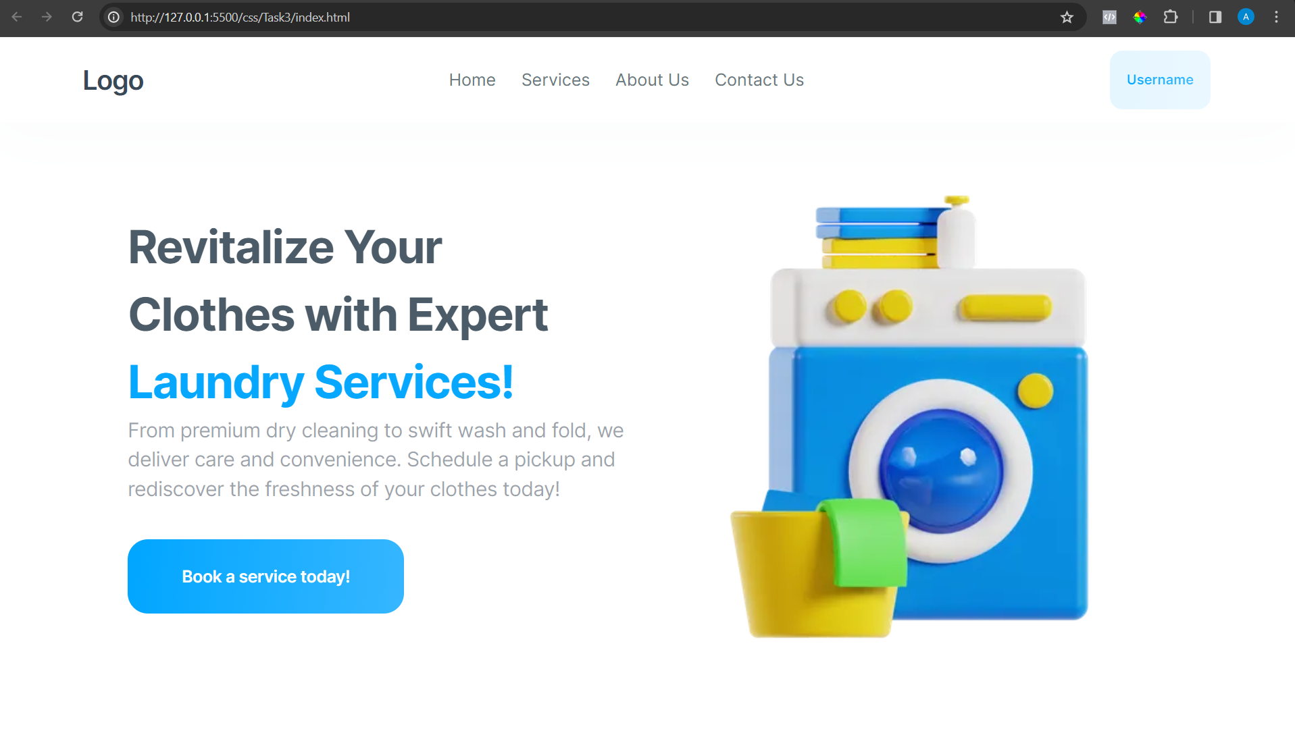

**Tablet :-**

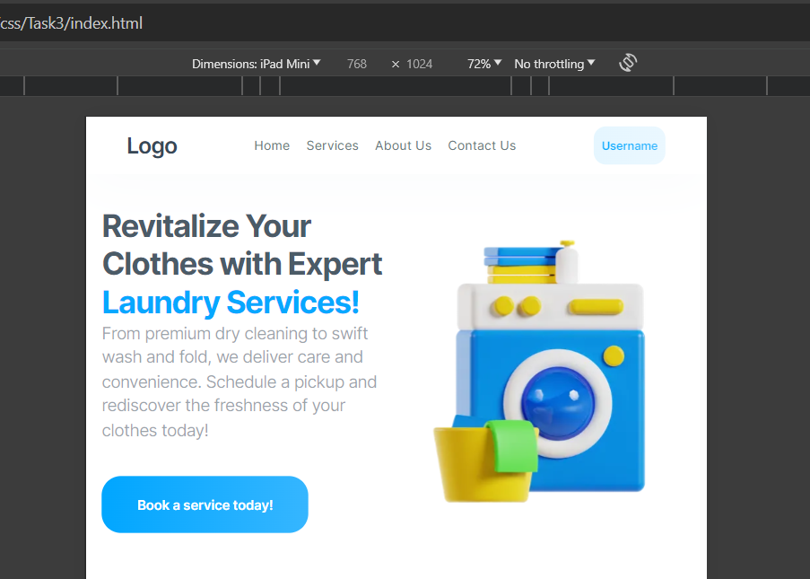

**Mobile:-**

